Bangladesh Medical Association (BMA)
List of Life Member-10
53. BMA Pirojpur Branch

Sl No | Voter No | Voter Details
1 | Voter No  LM-5300001  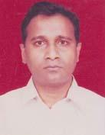 | DR. S.M MIZANUR RAHMAN BADAL  F/Name: Md. Abul Khair  M/Name: Mrs. Jahanara Begum  BM & DC Reg. No: 28565  NID: 7928007122597  Cell: 01716127335  Address: Desh Clinic & Nursing Home, Hospital Road, Pirojpur  Blood Group: B+
2 | Voter No  LM-5300002  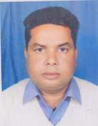 | DR. HANSHU PATI SIKDER  F/Name: Late. Ananda Lal Sikder  M/Name: Late. Bimala Rani Sikder  BM & DC Reg. No: 22987  NID: 7928007121352  Cell: 01711269390  Address: Govt. Quarter, MCWC, Pirojpur  Blood Group: O+
3 | Voter No  LM-5300003  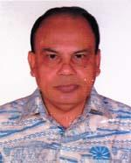 | DR. MUHAMMAD FAKHRUL ALAM.  F/Name:  M/Name:  BM & DC Reg. No: 14574  NID: 0695114202140  Cell: 01711358980  Address: civil; surgeon pirojpur  Blood Group: B+  TRANSFERED to BMA Dhaka City  LM-1405543
4 | Voter No  LM-5300004 | DR, SANKAR KUMAR GHOSE  F/Name: Niranjan Prosad Ghose.  M/Name: Lila Rani Ghose.  BM & DC Reg. No: 20290  NID: 7928004039646  Cell: 01716010036  Address: UH @ FPO, ZIANAGAR UHC ,PIROJPUR.  Blood Group: O+
5 | Voter No  LM-5300005 | DR. NANI GOPAL ROY.  F/Name: Hari Lal Roy.  M/Name: Renu Bala Kharati.  BM & DC Reg. No: 35989  NID: 7928004111921  Cell: 01914455503  Address: VILL. SHIKARPUR.PIS PIROJPUR  Blood Group: O+
6 | Voter No  LM-5300006  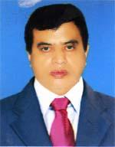 | DR. MD. SHAHADAT HOSSAIN HAZRA  F/Name: Md. Fazher Rahman Hazra.  M/Name: Late Shalia Begum .  BM & DC Reg. No: 20896  NID: 7928003126715  Cell: 01712094929  Address: UH FOP - UPAZILA HEALTAH COMPLEX, BHANDARIA PROJPUR.  Blood Group: A+
7 | Voter No  LM-5300007  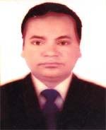 | DR. SHOURENDRA NATH SAHA.  F/Name: Late Suresh Chandra Saha.  M/Name: Paul Bala Saha.  BM & DC Reg. No: 24141  NID: 7911411802345  Cell: 01711230416  Address: MEDICAL OFFICER (MCHFP)-UPAZILA HEALTH COMPLEX ,BHANDARIA PIROJPUR.  Blood Group: A+
8 | Voter No  LM-5300008 | DR. RATAN KUMAR DHALI  F/Name: Manoranjan Dhali.  M/Name: Aruna Rani Dhali.  BM & DC Reg. No: 26613  NID: 7918738663497  Cell: 01917042331  Address: Upazila Health Conplex Nazirpur, Pirojpur.  Blood Group: O+
9 | Voter No  LM-5300009  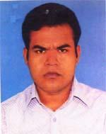 | DR. SWOMITRA SINGHA  F/Name: Suvash Chandra Singha  M/Name: Maya Mokhopadhyay  BM & DC Reg. No: 67180  NID: 7925802224046  Cell: 01722129846  Address: Suktara Building 2nd floor, T.N.T Road, Mathbaria Sadar, Pirojpur  Blood Group: B+
10 | Voter No  LM-5300010 | DR. MD. FERDOUS ISLAM  F/Name: Md. Bazlur Rahman  M/Name: Mrs. Nilufer Jahan  BM & DC Reg. No: 62308  NID: 2694266781254  Cell: 01735997999  Address: Desh Clinic & Nursing Home Hospital Pirojpur.  Blood Group: AB+

